**SOFTWARE ENGINEERING CONCEPTS – LAB MANUAL**

**WEB BASED REWARD POINT MANAGEMENT SYSTEM**

**SUBMITTED BY:**

**NAME** : ABILASH.M

**DEPT & SEC** : CSE ‘A’ (IInd year)

**ROLL_NO** : 2116220701006

RAJALAKSHMI ENGINEERING COLLEGE

RAJALAKSHMI NAGAR, THANDALAM – 602 105

BONAFIDE CERTIFICATE

Name:

Academic Year: Semester : Branch :

Register No:

*Certified that this is the bonafide record of work done by the above student*

*in the* CS19442 – *Software Engineering* *Laboratory during the year 2023-2024*

Signature of Faculty in-charge

Submitted for the Practical Examination held on

Internal Examiner External Examiner

A REPORT ON

WEB BASED

REWARD POINT

MANAGEMENT SYSTEM

|  |  |  |  |
| --- | --- | --- | --- |
| EX NO. | DATE | EXPERIMENT | PAGE NO. |
| 1 | 20-02-2024 | SRS | 2 |
| 2 | 01-03-2024 | SCRUM METHODOLOGY | 7 |
| 3 | 12-03-2024 | USER STORIES | 9 |
| 4 | 19-03-2024 | USE CASE DIAGRAM | 11 |
| 5 | 29-03-2024 | NFR | 12 |
| 6 | 09-04-2024 | OVERALL PROJECT ARCHITECTURE | 14 |
| 7 | 19-04-2024 | BUSINESS ARCHITECTURE | 15 |
| 8 | 30-04-2024 | CLASS DIAGRAM | 18 |
| 9 | 10-05-2024 | SEQUENCE DIAGRAM | 19 |
| 10 | 17-05-2024 | ARCHITECTURAL PATTERN | 20 |

INDEX

REWARD POINT MANAGEMENT SYSTEM

OVERVIEW OF THE PROJECT

Statistics show that 70% of all projects fail, with one significant contributing factor being the lack of effective project management tools and practices. Additionally, 42% of companies don't understand the need for setting target milestones thus leading to inefficiencies and exhaustion of resources. Organizations and teams working on projects often struggle with tracking progress, evaluating performance, and ensuring that milestones are met on time. Effective project management and evaluation are crucial for the successful completion of projects.To overcome this problem, an effective software tool that could streamline the different components of an ongoing project and provide functionalities for setting targets and tracking progress is required.Such a tool would increase success rates drastically and enable organisations to grow exponentially.

SOFTWARE REQUIREMENTS SPECIFICATION

EXP_NO: 1 DATE: 20-02-24

1. Introduction

The Employee Reward Point Management System is a web-based platform designed to motivate and recognize employees' achievements through a point-based reward system. The system allows employees to submit tasks, track their progress, and earn points based on their performance, while managers can oversee the entire process, ensuring a fair and transparent evaluation of employee performance.

Purpose:

The purpose of the Employee Reward Point Management System is to provide a centralized platform for employee recognition and reward, encouraging employees to prioritize tasks, meet deadlines, and strive for excellence. The system aims to boost employee morale, motivation, and job satisfaction, ultimately contributing to improved productivity and business performance.

1. Scope

The scope of the Employee Reward Point Management System includes the following key features:

* Employee login to view total points, leaderboard, and submit tasks
* Automated point system based on task submission deadlines
* Manager login (admin login) to oversee employee performance and reward points
* Database connectivity to store employee data, task submissions, and reward points.
* User-friendly interface for easy navigation and use.

3.Functional Requirements

3.1.User Authentication and Authorization

* Employees and managers must register and create their respective accounts.
* Employees and managers must log in using their credentials to access the system.
* The system must enforce password complexity requirements and provide secure password storage.
* The system must implement a session management mechanism to ensure secure user authentication.
* The system must provide a password reset functionality for users who forget their passwords.
* The system must enforce user roles and permissions, restricting access to specific features based on user type.

Task Management:

* The system must allow employees to submit tasks related to specific projects.
* The system must allow employees to view the status of their submitted tasks.
* The system must automatically assign points to employees based on the timely completion of tasks.

3.2. Project Management

* The system must allow managers to create, edit, and delete projects.
* The system must display a list of projects for employees to view and select tasks from.
* The system must allow managers to assign employees to specific projects.
* The system must allow managers to set project deadlines and priorities.
* The system must allow managers to create, edit, and delete milestones for each project.
* The system must allow employees to view the milestones associated with each project.
* The system must allow employees to submit tasks related to specific milestones.
* The system must automatically assign points to employees based on the timely completion of milestones.

4 . Report generation

* The system must generate reports on employee performance, including total points, leaderboard position, and task completion rate.
* The system must allow managers to view reports on team performance, including overall progress, completed milestones, and pending tasks.
* The system must provide customizable report filters based on date range, user type, and project status.

1. Non -Functional Requirements

5.1. Performance

* The system must provide fast response times, with a maximum response time of 3 seconds for any user action.
* The system must support a minimum of 100 concurrent users without experiencing performance degradation.

5.2. Security

* The system must use secure communication protocols, such as HTTPS, to protect user data in transit.
* The system must implement appropriate access controls and authentication mechanisms to prevent unauthorized access.
* The system must comply with relevant data protection regulations, such as GDPR or CCPA.

5.3. Usability

* The system must provide a user-friendly interface, with intuitive navigation and clear instructions.
* The system must support multiple languages to cater to a global user base.
* The system must provide appropriate feedback to users, such as success or error messages, to help them understand the outcome of their actions.

5.4. Scalability

* The system must be designed to support future growth, with the ability to add new users, projects, and tasks without significant performance degradation.
* The system must be able to handle large volumes of data, with appropriate data storage and retrieval mechanisms.

5.5. Reliability

* The system must provide high availability, with a minimum uptime of 99.9%.
* The system must implement appropriate backup and disaster recovery mechanisms to ensure data integrity and availability.

5.6. Compatibility

* The system must be compatible with multiple devices, including desktop computers, laptops, tablets, and smartphones.
* The system must support multiple browsers, including Chrome, Firefox, Safari, and Edge.

5.7.Constraints

* It should be compatible with commonly used web browsers and operating systems.
* The software should be capable of integrating with existing project management tools, collaboration platforms, and third-party services commonly used in project environments.

6. Conclusion

By meeting the outlined requirements, the software will facilitate informed decision-making and contribute to the successful completion of projects. In conclusion, By incorporating all the considerations into the SRS, the software can better meet the diverse needs and requirements of project stakeholders, ultimately contributing to the successful delivery of projects.

**EXP_NO:**

**2**

**AGILE SCRUM - METHODOLOGY**

**DATE:01**

**-**

**03**

**-**

**24**

**1.**

**Product Backlog**

and

functionalities

defines

The

product

backlog

the

different

features

the

website

intends

to

achieve.It

outlines

the

value

that

the

website

woul

d

add to the users.

**1**

**.1.**

**U**

**ser Authentication and Access**

**1**

**.Project Management**

**.2**

**1**

**.3**

**.Milestone Management**

**1**

**.4**

**.Evaluation of Attainment of Milestones**

**1.5**

**.Report Generation**

**2**

**.Scrum**

**Backlog**

**Sprint 1**

**(2**

**weeks**

**)**

**Sprint**

**Goal**

authentication

and

project

:

Implement

basic

user

management

functionalities.

**User Authentication and Authorization**

**Task 1**

:

Set up user registration form and backend logic.

**Task 2**

:

Design and implement role

-

based access

control system.

**Sprint 2**

**(3**

**weeks**

**)**

**Sprint Goal:** Set up Basic Point Tracking.

**Basic Point Tracking**

**Task 3:** Develop the backend logic for tracking earned and redeemed points.

**Task 4:** Create API endpoints for retrieving and updating user point balances.

**Task 5:** Implement basic UI for users to view their current point balance.

**Sprint 3(4 weeks)**

**Sprint Goal:** Implementation of earn points functionality.

**Earn Points Functionality**

**Task 6:** Define and implement mechanisms for users to earn points (e.g., making purchases, referrals, social sharing).

**Task 7:** Integrate point earning logic with relevant parts of the application (e.g., checkout process for purchases).

**Redeem Points Functionality**

**Task 8:** Enable users to redeem points for rewards or discounts.

**Task 9:** Develop a catalog of available rewards and their point values.

**Task 10:** Implement backend logic for handling point redemption transactions.

**Sprint 4(3 weeks)**

**Sprint Goal:** To deploy

**Deployment and Final polish**

**Task 11:**Prepare the system for production and deployment

**USER STORIES**

EXP_NO: 3 DATE: 12-04-24

**User Story 1**: Employee Login and View Points

As an employee, I want to log in to the system so that I can view my total reward points.

Acceptance Criteria:

The employee can log in using their credentials.

Upon successful login, the employee is directed to their dashboard.

The dashboard displays the employee's total reward points.

If the login fails, an appropriate error message is shown.

**User Story 2**: Employee Submits a Task

As an employee, I want to submit my completed tasks so that I can earn or lose points based on the submission deadline.

Acceptance Criteria:

The employee can access a task submission form.

The employee can enter task details and submit the form.

The system checks the submission date against the task deadline.

Points are awarded or deducted automatically based on the submission date.

The employee receives a confirmation message indicating the task submission status and points earned or lost.

**User Story 3**: Employee Views Leaderboard

As an employee, I want to view the leaderboard so that I can see the top point scorers in the company.

Acceptance Criteria:

The employee can access the leaderboard from their dashboard.

The leaderboard displays a ranked list of employees based on their total points.

The employee's position on the leaderboard is highlighted.

The leaderboard is updated in real-time as points are awarded or deducted.

**User Story 4**: Manager Manages Tasks

As a manager, I want to create and manage tasks so that I can assign them to employees and set deadlines.

Acceptance Criteria:

The manager can log in using their credentials.

The manager can access the task management interface.

The manager can create new tasks, specifying task details and deadlines.

The manager can edit or delete existing tasks.

Employees are notified of new tasks assigned to them.

**User Story 5:** Manager Views Employee Performance

As a manager, I want to view the performance of employees so that I can evaluate their productivity and reward points.

Acceptance Criteria:

The manager can access an employee performance dashboard.

The dashboard displays a list of employees with their total points and task completion status.

The manager can filter and sort the list based on different criteria (e.g., highest points, most tasks completed).

**USE CASE DIAGRAM**

EXP_NO: 4 DATE:19-03-24

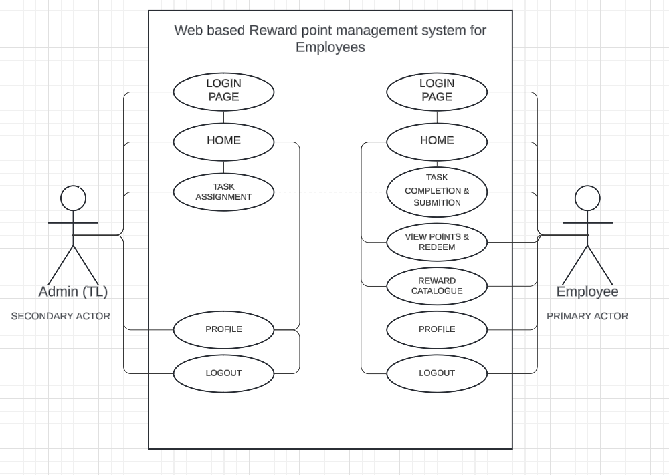

**NFR - Non Functional Requirement**

EXP_NO: 5 DATE:29-03-24

1.  Performance

* The system must provide fast response times, with a maximum response time of 3 seconds for any user action.
* The system must support a minimum of 100 concurrent users without experiencing performance degradation.

2. Security

* The system must use secure communication protocols, such as HTTPS, to protect user data in transit.
* The system must implement appropriate access controls and authentication mechanisms to prevent unauthorized access.
* The system must comply with relevant data protection regulations, such as GDPR or CCPA.

3. Usability

* The system must provide a user-friendly interface, with intuitive navigation and clear instructions.
* The system must support multiple languages to cater to a global user base.
* The system must provide appropriate feedback to users, such as success or error messages, to help them understand the outcome of their actions.

4. Scalability

* The system must be designed to support future growth, with the ability to add new users, projects, and tasks without significant performance degradation.
* The system must be able to handle large volumes of data, with appropriate data storage and retrieval mechanisms.

5. Reliability

* The system must provide high availability, with a minimum uptime of 99.9%.
* The system must implement appropriate backup and disaster recovery mechanisms to ensure data integrity and availability.

6. Compatibility

* The system must be compatible with multiple devices, including desktop computers, laptops, tablets, and smartphones.
* The system must support multiple browsers, including Chrome, Firefox, Safari, and Edge.

**OVERALL ARCHITECTURE**

EXP_NO: 6 DATE:09-04-24

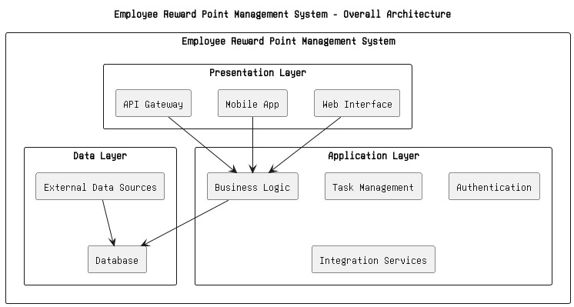

**BUSINESS ARCHITECTURE**

**EXP_NO: 7**

**DATE:19**

**-**

**04**

**-**

**24**

**Current Process**

website,

the

Before

the

implementation

of

the

project

milestone

evaluation

process might involve manual method

s or disparate tools for managing projects,

milestones, and reports. For example:

•

Project

Management:

Teams

may

use

spreadsheets

or

documents

to

track

project details, tasks, and deadlines.

•

Milestone

Management:

Milestones

may

be

tracked

manually,

wit

h

notifications or reminders managed separately.

•

generated

Report

Generation:

Reports

may

be

manually,

requiring

data

collection from various sources and manual compilation.

**Personas and Their Current Processes**

Different personas within the organization

have varying roles and interactions

with the current processes:

•

progress,

they

may

Project

Managers:

Responsible

for

overseeing

project

communicating

with

team

spend

significant

time

updating

spreadsheets,

members, and generating reports.

•

Team

Members

:

Engaged

in

executing

project

tasks,

they

rely

on

project

managers for task assignments and milestone updates.

•

Administrators: Handle user access, permissions, and system configurations,

often managing these manually or through separate tools.

* Stakeholders: Require visibility into project progress and milestone achievements, often relying on periodic reports or updates from project managers.

Business Problems

The current processes present several challenges and inefficiencies:

* Manual Effort: The reliance on manual methods for project, milestone, and report management leads to time-consuming data entry, updates, and report generation.
* Data Discrepancies: Disparate tools or manual methods may result in inconsistencies or errors in project data, affecting decision-making and project outcomes.
* Lack of Transparency: Limited visibility into project progress and milestone achievements may lead to misunderstandings or delays in project delivery.
* Limited Scalability: Manual processes or disparate tools may not scale effectively as the organization grows or as project complexity increases.

By addressing these business problems, the project milestone evaluation website aims to automate and streamline project management processes, improve data accuracy and transparency, and enhance collaboration and decision-making across the organization.

**BUSINESS ARCHITECTURE DIAGRAM**

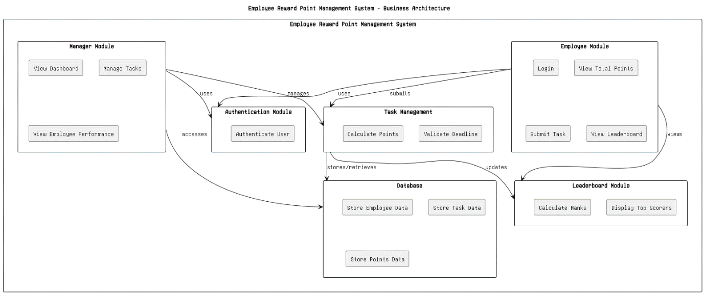

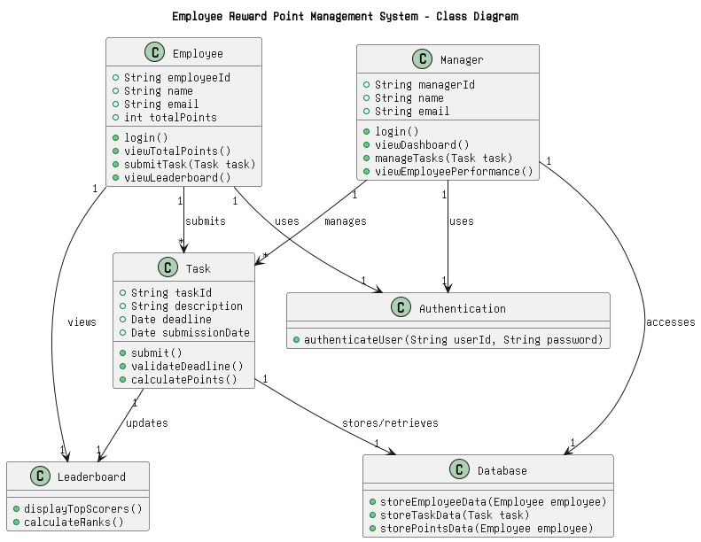

**CLASS DIAGRAM**

**EXP_NO:**

**8**

**DATE:**

**30**

**-**

**04**

**-**

**24**

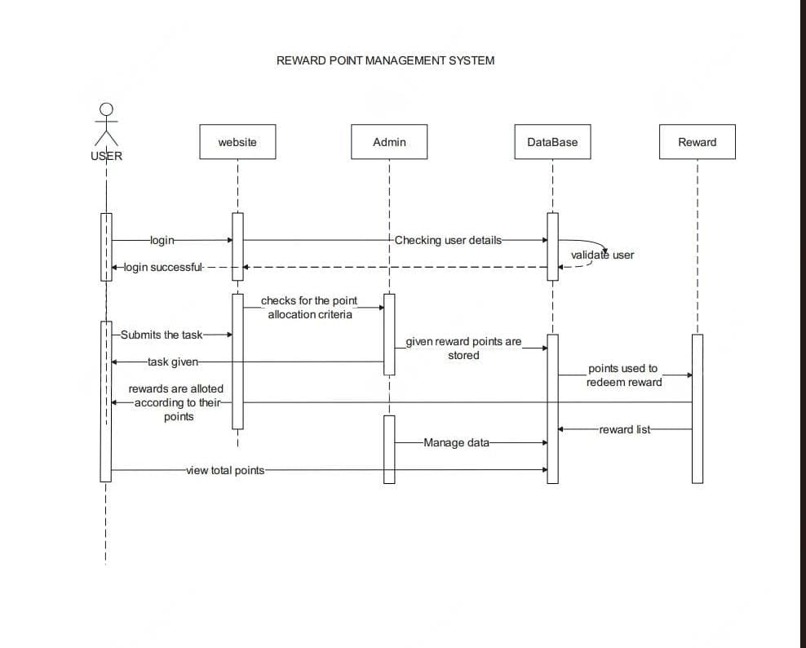

**SEQUENCE DIAGRAM**

**EXP_NO: 9**

**DATE:10**

**-**

**05**

**-**

**24**

**ARCHITECTURAL PATTERN-MODEL VIEW CONTROLLER**

EXP_NO: 10 DATE:17-05-24

The Employee Reward Point Management System can be implemented using the Model-View-Controller (MVC) architectural pattern. The MVC pattern separates the application into three interconnected components: the Model, the View, and the Controller.

1. Model: The Model represents the data and business logic of the application. In the context of the Employee Reward Point Management System, the Model includes the database schema, data access layer, and business logic layer. The Model is responsible for managing the data and performing operations such as creating, reading, updating, and deleting records.
2. View: The View represents the user interface of the application. In the context of the Employee Reward Point Management System, the View includes the web pages, forms, and reports that the users interact with. The View is responsible for displaying the data and providing a user-friendly interface for the users to interact with the application.
3. Controller: The Controller acts as an intermediary between the Model and the View. The Controller is responsible for handling user requests, processing input, and updating the Model. In the context of the Employee Reward Point Management System, the Controller includes the web controllers that handle user requests, process input, and update the Model.

The MVC pattern provides several benefits for the Employee Reward Point Management System, including:

* Separation of concerns: The MVC pattern separates the application into three distinct components, making it easier to maintain and update the application.
* Reusability: The Model and View components can be reused across different applications, making it easier to develop new applications.
* Scalability: The MVC pattern allows for the addition of new features and functionality without affecting the existing components.
* Testability: The MVC pattern makes it easier to test the application by separating the components and allowing for unit testing.

In summary, the Employee Reward Point Management System can be implemented using the MVC architectural pattern, which separates the application into three interconnected components: the Model, the View, and the Controller. The MVC pattern provides several benefits, including separation of concerns, reusability, scalability, and testability.

**ARCHITECTURE PATTERN DIAGRAM**

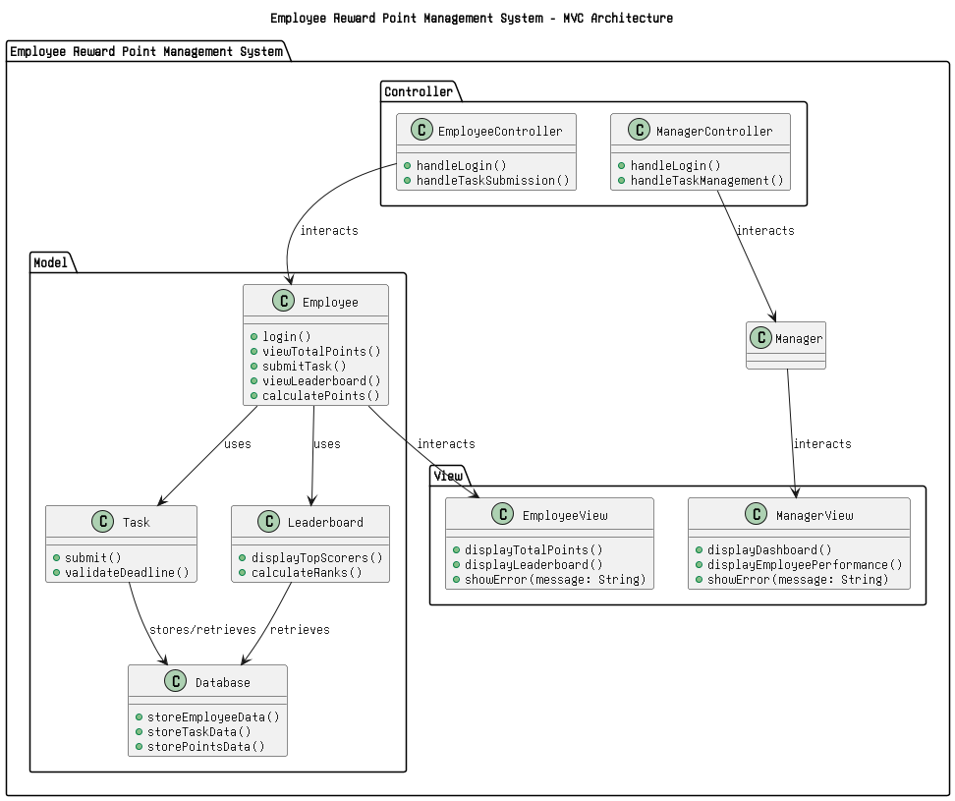

TEAM MEMBERS:

1. ARVINDH.V(220701030)
2. ADHESH.M(220701020)
3. AJAY KRISHNAN(220701018)
4. ABILASH.M(220701006)
5. BALAJI.G(220701036)
6. AMALLESH.B(220701024)